**Problem of the Week # 9**

**Palindrome Dates**

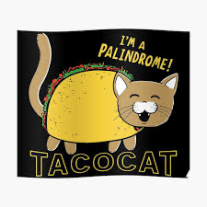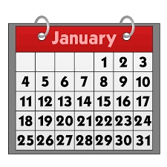

A **palindrome** is a word or phrase or number that reads the same forward or backward. The date December 9, 2021 can be written 12-9-21. And if you remove the hyphens, the date would be written 12921 forward or backward.

**What future dates in 2022 will be palindromes?**

**Write as many as you can.**